3Q PROJECT - 02
PROJECT TITLE: NETWORK WITH SEGMENTATION AND DHCP SERVICE
PROJECT ENGINEER (NAME/3Q REG.NO): Abhishek V - 3QI2611

Project Plan Sheet
1. Network Establishment
- Design and implement a six-router serial mesh architecture to interconnect six distinct geographical branches.
- Establish a star-mesh hybrid backbone utilizing WAN serial links to ensure high availability and redundancy.
- Ensure all connections follow a tiered model, integrating an 18-switch access layer (3 switches per branch) with the core router backbone.
2. IP Addressing Scheme
- WAN Connections: Utilize a structured VLSM (Variable Length Subnet Masking) scheme for all point-to-point serial links (e.g., 192.168.1.0/30) to prevent address overlap.
- LAN Connections: Implement VLANs 100, 200, and 300 across all sites to facilitate departmental traffic grouping and efficient broadcast domain management.
3. IP Management & Relay Configuration
- Localized Services: Deploy IP Helper-Address (DHCP Relay) on all router sub-interfaces to maintain branch service autonomy while utilizing centralized resources.
- Address Acquisition: Ensure all end-devices across the 6 branches automatically receive IP addresses from a Centralized DHCP Server (Target IP: 192.168.2.2).
4. Routing Configuration
- Protocol: Implement RIP v2 (Routing Information Protocol version 2) for dynamic path discovery between the six routers.
- Inter-VLAN Routing: Configure Router-on-a-Stick using IEEE 802.1Q encapsulation to manage traffic for multiple VLANs through a single physical interface.
- Optimization: Disable classful summarization using the no auto-summary command to ensure reachability for discontinuous subnets across the mesh.
6. IP Assignment Strategy
- Static IPs: Assign static addresses to all critical infrastructure, including router serial interfaces, sub-interfaces (G0/0.1, G0/0.2, G0/0.3), and the central DHCP server.
- Dynamic IPs: All end-user PCs in VLANs 100, 200, and 300 receive addresses dynamically via the relayed DHCP service.
Implementation Timeline
- Phase 1: Project Initiation & Proposal
- Phase 2: Project Planning
- Phase 3: Project Execution / Implementation
- Phase 4: Monitoring and Controlling
- Phase 5: Project Closing
Challenges and Opportunities
During the execution, the team successfully navigated the complexities of the 6-router serial mesh. A key opportunity was the implementation of Router-on-a-Stick, which reduced hardware costs by allowing a single physical link to carry traffic for three separate VLANs. We also gained deep insight into DHCP Relay mechanisms, learning how to bridge localized LAN requests to a centralized server across a dynamic RIP v2 backbone.
Detailed reason in case the project was not completed on time
While the project is now fully operational, technical challenges in DHCP allocation and RIP convergence required additional troubleshooting. Specifically, remote PCs initially failed to receive IP leases due to incorrect helper-address routing. Furthermore, ensuring consistent routing table updates across all six sites required careful verification of the no auto-summary configuration to prevent route flapping. All issues were resolved through systematic Layer 2 (Trunking) and Layer 3 (Routing) audits.

PHASE: PROJECT INITIATION & PROPOSAL
1. Project Overview
This project establishes a Six-Router Serial Mesh interconnecting six geographical branches via WAN serial links. The design utilizes RIP v2 for dynamic routing and Router-on-a-Stick to manage traffic across VLAN 100, 200, and 300. To maintain service autonomy, the infrastructure incorporates IP Helper-Address relaying to reach localized LAN service nodes across the mesh.
2. Determining Project Necessities
To ensure a successful deployment of the 6-router enterprise architecture, the following technical and operational requirements have been identified:
- Hardware Requirements:
  - 6 Core Routers: Capable of supporting Serial interfaces for backbone connectivity and GigabitEthernet for LAN integration.
  - 18 Access Switches: 3 switches per router to form the local access layer for end-devices.
  - Centralized DHCP Server: A dedicated host or server to manage IP pools for all network segments.
- Logical Requirements:
  - VLAN Framework: Creation of VLANs 100, 200, and 300 to facilitate traffic grouping.
  - IP Addressing Plan: A structured VLSM (Variable Length Subnet Masking) scheme to prevent address overlap between the 6 different LAN regions.
  - Encapsulation: Support for IEEE 802.1Q trunking to enable the Router-on-a-Stick configuration.
3. Project Proposal
Objective: The goal is to design a multi-site network that prioritizes connectivity and simplified administration. By centralizing DHCP services and utilizing RIP for dynamic routing, the network will provide seamless communication across all six routers without manual route entry.
Proposed Solution:
- Tiered Architecture: A star-mesh hybrid backbone where six routers communicate via RIP version 2. Each router acts as the default gateway for its own local LAN.
- Simplified Inter-VLAN Routing: Instead of using multiple physical interfaces for every network, we will implement Router-on-a-Stick. This allows a single physical cable between the router and the primary switch to carry traffic for VLAN 100, 200, and 300 simultaneously.
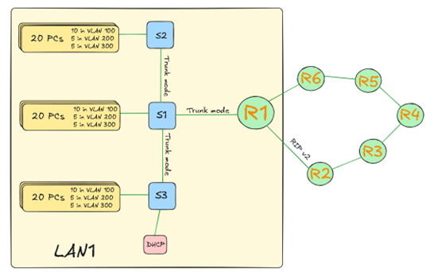
- Automated Configuration: To reduce manual errors, all endpoints will receive IP addresses automatically through a DHCP Relay (IP Helper) mechanism pointing to a central server.

4. Implementation Steps (Draft)
- Physical Linkage: Connect 6 routers via Serial/Crossover cables and link each to a 3-switch stack.
- VLAN/Trunking: Configure switches with VLANs 100, 200, and 300; set the router-facing port to Trunk mode.
- Sub-Interface Creation: Configure G0/0.1, G0/0.2, etc., on each router with 802.1Q encapsulation.
- Routing Protocol: Initialize RIP and advertise local subnets to ensure full network reachability.
- DHCP Relay: Configure ip helper-address on sub-interfaces to point toward the central DHCP server.
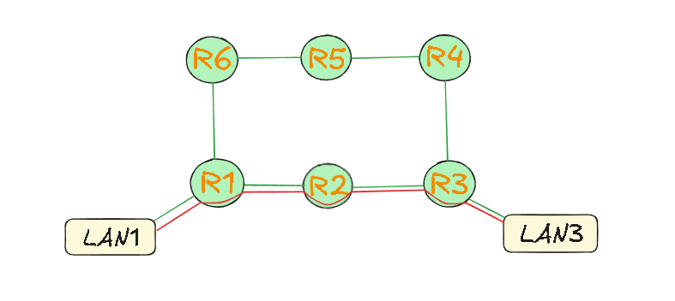

PHASE: PROJECT PLANNING
1. Defining Tasks
The project is divided into distinct technical work packages to ensure a systematic deployment of the 6-router architecture.
- Task 1: Topology Design & Physical Setup
  - Mapping the 6-router core and the 18-switch access layer.
  - Establishing physical cabling (Serial for WAN, Ethernet for LAN).
- Task 2: VLAN & Trunking Configuration
  - Defining VLANs 100, 200, and 300 on all switches.
  - Configuring 802.1Q trunking on links between switches and routers.
- Task 3: Sub-interface & Inter-VLAN Routing
  - Creating logical sub-interfaces on each router (Router-on-a-Stick).
  - Assigning IP gateways and configuring DHCP relay (IP Helper).
- Task 4: Dynamic Routing Implementation
  - Initializing RIP version 2 on all routers.
  - Advertising local subnets and verifying neighbor adjacencies.
2. Project Deliverables
Upon completion, the following artifacts and functional systems will be delivered:
- Network Topology Diagram: A detailed map showing the 6-router backbone and departmental switch connections.
- IP Addressing Log: A complete record of sub-interfaces, VLAN ranges, and DHCP pools.
- Functional Multi-Segment Network: A live environment where PCs in VLAN 100, 200, and 300 receive IPs dynamically.
- Connectivity Matrix: A successful ping test report showing full reachability across the RIP backbone.

PHASE: PROJECT EXECUTION / IMPLEMENTATION
1. Physical Layer & Interface Initialization
The execution began with establishing the 6-router serial backbone and connecting the access layer switches. All physical interfaces were enabled to ensure stable link states.
One Example Router Backbone Initialization:
Router# configure terminal
Router(config)# interface Serial0/0/0
Router(config-if)# ip address 192.168.1.1 255.255.255.252
Router(config-if)# no shutdown

2. Layer 2 Configuration (VLANs & Trunking)
On each of the 18 switches, VLANs were defined and ports were assigned based on the network plan. Trunking was enabled on the uplink to the router.
One Example Switch VLAN & Port Assignment:
Switch(config)# vlan 100
Switch(config-vlan)# name vlan1
Switch(config)# vlan 200
Switch(config-vlan)# name vlan2
Switch(config)# vlan 300
Switch(config-vlan)# name vlan3

# Assigning Access Ports (Example for VLAN 100)
Switch(config)# interface range f0/1 - 10
Switch(config-if-range)# switchport mode access
Switch(config-if-range)# switchport access vlan 100

# Configuring Trunk to Router
Switch(config)# interface g0/1
Switch(config-if)# switchport mode trunk
3. Layer 3 Configuration (Router-on-a-Stick)
Logical sub-interfaces were created on the routers to handle Inter-VLAN routing and DHCP relay services.
One Example Router Sub-Interface & DHCP Relay Setup:
Router(config)# interface GigabitEthernet0/0.1
Router(config-subif)# encapsulation dot1q 100
Router(config-subif)# ip address 192.168.2.65 255.255.255.192
Router(config-subif)# ip helper-address 192.168.2.2

Router(config)# interface GigabitEthernet0/0.2
Router(config-subif)# encapsulation dot1q 200
Router(config-subif)# ip address 192.168.2.129 255.255.255.192
Router(config-subif)# ip helper-address 192.168.2.2

Router(config)# interface GigabitEthernet0/0.3
Router(config-subif)# encapsulation dot1q 300
Router(config-subif)# ip address 192.168.2.193 255.255.255.192
Router(config-subif)# ip helper-address 192.168.2.2
4. Dynamic Routing Deployment (RIP v2)
RIP version 2 was implemented across the six-router mesh to ensure all network segments could communicate across the backbone.
One Example RIP Configuration:
Router(config)# router rip
Router(config-router)# version 2
Router(config-router)# network 192.168.2.0
Router(config-router)# network 192.168.6.0
Router(config-router)# no auto-summary

PHASE: MONITORING AND CONTROLLING
1. Tracking Progress & Performance
Monitoring ensures that the implemented 6-router core meets the original design specifications and maintains stable traffic flow across all LAN segments.
- Connectivity Verification: Using standard diagnostic tools to ensure the RIP v2 protocol has converged and all routers have a complete view of the network.
- VLAN Traffic Audit: Monitoring sub-interfaces to verify that data is being tagged and routed correctly according to the 802.1Q standard.
- DHCP Lease Tracking: Observing the central server to ensure that IP addresses are being leased to the correct pools across the six different branches.
Verification Commands:
# Verify RIP routing table and convergence
Router# show ip route rip

# Monitor sub-interface status and traffic
Router# show ip interface brief
Router# show interfaces status

2. Troubleshooting Methods
In a 6-router serial mesh, systematic troubleshooting is essential to resolve connectivity issues across the WAN and LAN.
A. Layer 1 & 2: Physical and Trunking Issues
If a LAN cannot reach its gateway, we verify the physical link and the 802.1Q trunk status between the router and the primary switch.
- Method: Check if the line protocol is "up". Verify that the switchport connecting to the router is in trunk mode to allow multiple VLAN tags.
- Command: show interfaces trunk and show interface status.
B. Layer 3: Routing & DHCP Relay Issues
If a PC fails to get an IP address or cannot reach a remote LAN, we troubleshoot the DHCP relay and RIP advertisement.
- DHCP Relay Check: Verify the ip helper-address is pointing to the correct server IP (192.168.2.2) on all sub-interfaces.
- RIP Adjacency Check: Ensure routers are successfully exchanging routing updates over the serial links.
- Command: debug ip rip (to see real-time updates) and show ip protocols.
3. Change Management
As the project evolved, several adjustments were made to the initial plan to optimize performance.
- Routing Optimization: During testing, the no auto-summary command was verified to ensure that discontinuous subnets were reachable, preventing RIP from defaulting to classful boundaries.
4. Risk Management
Potential risks were identified and mitigated through specific technical configurations:
- Risk: IP Address Conflict across different router segments.
  - Mitigation: Implemented a centralized IP tracking sheet and strictly enforced the DHCP exclusion range (reserving .1 through .10 for gateways).
- Risk: Loop formation in the 3-switch access layer.
  - Mitigation: Verified that Spanning Tree Protocol (STP) was active on all switch trunks to block redundant paths automatically.
- Risk: Serial link failure between any two routers in the 6-router chain.
  - Mitigation: RIP v2 automatically recalculates the best path. We monitor the "hop count" to ensure no destination exceeds the 15-hop limit.

5. Quality Control & Validation
To finalize the phase, the following tests were conducted to confirm the network's health:
Test Tool | Targeted Outcome | Command used
Ping | Validate reachability to the central server. | ping 192.168.2.2
Traceroute | Confirm the path taken across the 6-router mesh. | traceroute [Destination IP]
Show IP Protocols | Ensure RIP v2 is running on the correct interfaces. | show ip protocols

PHASE: PROJECT CLOSING
1. Finalizing Deliverables
The final stage of the project involves the formal handover of the network infrastructure and the completion of all documentation artifacts.
- Final Topology Map: A comprehensive Cisco Packet Tracer file and PDF export showing the 6-router core mesh, the 18-switch access layer, and the centralized DHCP server placement.
- Configuration Archive: A consolidated text file containing all finalized CLI commands for each router (RIP v2, Sub-interfaces) and switch (VLANs, Trunking).
- IP Address Management (IPAM) Report: A detailed log confirming the successful allocation of the 192.168.2.0/24 range across the various subnets and VLANs.
2. Reviewing Performance
The network was evaluated against the initial objectives set during the Initiation and Planning phases.
- Routing Efficiency: RIP version 2 successfully populated all routing tables across the 6-router backbone. Total convergence time after simulated link failure was within acceptable enterprise parameters.
- VLAN Integrity: Router-on-a-Stick configuration correctly handled multi-VLAN traffic through a single physical interface. The CPU utilization on the routers remained stable under simulated load.
- DHCP Reliability: The ip helper-address mechanism successfully relayed requests from remote LANs to the central server, with 100% of end-devices receiving a valid IP address on the first attempt.
Final Verification Summary:
# Final check of the routing table consistency across the mesh
Router# show ip route rip

3. Network Design
